Worksheet IP.5 – Image Compression– Solutions

Question 1. A 4656 x 3492 color image is saved as a jpeg file. The file size is 5.5323 MB. Calculate the relative data redundancy.

Question 2. [Adapted from DIP book]
The normalized histogram of the following image is shown in Table 8.1 [DIP book]. Calculate the compression rate using (a) the best fixed length code, and (b) Code 2.
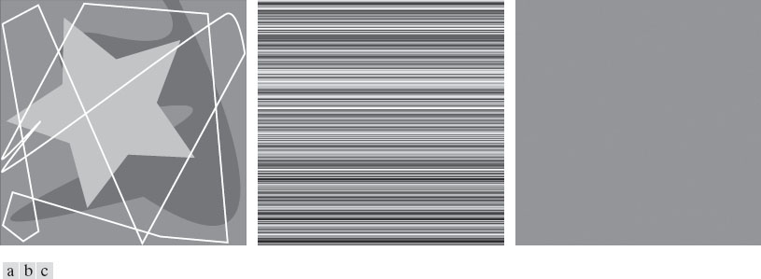
Table 8.1 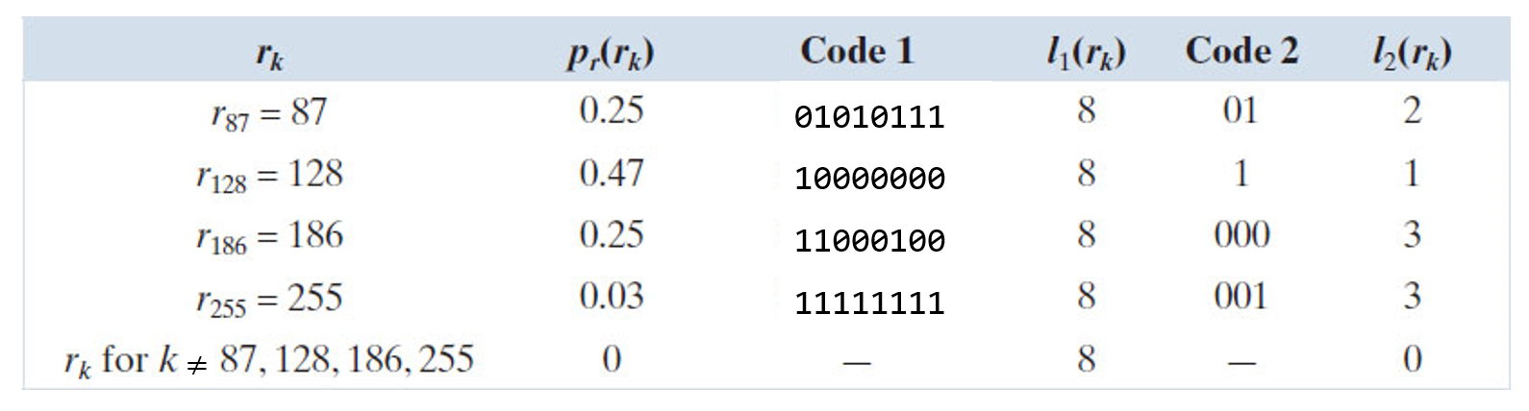

Question 3. [Adapted from DIP book]
Consider a 256 x 255 image with each of the 256 rows having a unique intensity level from 0 to 255. What type of redundancy exists in this image? How can it be compressed? And what is the compression rate using this method?

Question 4. [Adapted from DIP book]
Assuming a zero-memory source, what is the highest compression rate achievable for the image in question 2?

Question 5. [Adapted from DIP book]
In an image you have 6 different levels of intensity shown as symbol a1 to a6, with their normalized histogram (probabilities) as follows:
Symbol | Probability
a₁ | 0.1
a₂ | 0.4
a₃ | 0.06
a₄ | 0.1
a₅ | 0.04
a₆ | 0.3

- Construct the Huffman tree for the given symbols.
- Assign binary Huffman codes to each symbol.
- Compute the average code length.
- Decode 010100111100 using codewords created in step b.

Question 6. [Adapted from DIP book]
Use arithmetic coding to code the sequence: $a_{1}a_{2}a_{3}a_{3}a_{4}$.

